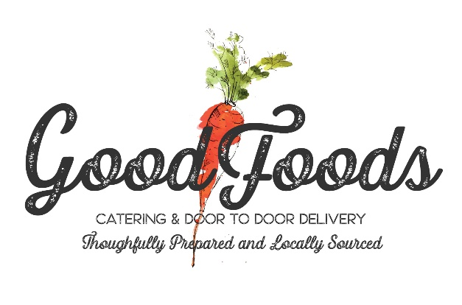
Good Foods ~ Individually Packaged Gourmet Meals
All orders must be placed 48 hours in advance. 12-meal minimum per style of meal. A $25.00 delivery fee, 18% administration fee and applicable sales tax will be
added to all delivery orders. Please call your event coordinator directly or call the main number 720-334-0859 to place orders. On-line ordering will be
available by January 1, 2022

Good Foods ~ Bistro Box Lunches
Bistro Lunches presented in decorative gift boxes with tissue, wrapped silverware, napkins, and sanitizer hand-wipes. Chef’s salad of the day, seasonal fresh fruit salad and petite desserts from the bake shop also included. All Lunches available
gluten free for an additional $1.00

French Parisian Turkey: Roasted turkey on French baguette with red pepper and Brie smear, arugula and tomato. $13.95
Colorado Pork Loin: Thin sliced roasted pork loin on French baguette with green chili strips, pepper jack cheese and black pepper aioli. $13.95
Italian Grinder: Pepperoni, salami, mortadella on Italian roll with arugula parmesan smear, fresh arugula, and provolone cheese. $13.95
Tuscan Chicken Salad: Roasted chicken salad on croissant with arugula, Roma tomato and fresh herb aioli. $13.95
Good Foods Garden Veggie: Sauteed seasonal vegetables on croissant with fresh spinach, cucumber, tomato slices and avocado smear. $12.95
Classic Roast Beef: Thinly sliced Medium Rare Roast Beef piled high served on a sliced Baguette with micro green, Roma tomato, provolone cheese and fresh herbed Dijon herb remoulade. $14.95
Country Ham and Swiss: Honey Smoked Ham piled high with Swiss cheese, micro greens, Roma tomato on croissant with Dijon herb remoulade. $13.95
Caprese Vegetarian Sandwich: Fresh Mozzarella, seasonal sliced tomatoes, roasted yellow bell peppers, fresh basil, with a smear of sun-dried tomato pesto and balsamic drizzle served on a sliced baguette. $14.95
Good Foods Fresh Deli Sandwich and Weekly Gourmet Soup ~ Handle Bags: Choice of Deli Sandwich ~ Choice of Roasted Turkey & Cheddar; Ham & Swiss; Roast Beef & Provolone; and Veggie with Provolone, Cheddar and Seasonal Veggies

All sandwiches made on Deli Roll with greens, Roma tomato and Dijonnaise smear.
Handle Bags include Oyster Crackers and Fresh Baked Chunk Cookie, wrapped silverware, napkins, and sanitizer hand-wipes. $12.95
Bags available gluten free for an additional $1.00

Good Foods Farm to Table Salads
Farm to Table Salads presented in decorative gift bags with tissue, wrapped silverware, napkins, and sanitizer hand-wipes. Seasonal fresh fruit salad, sliced French baguette and petite desserts from the bake shop included.
Gluten Free crackers available upon request.

Good Foods Chop Salad: Crisp Romaine, Baby Spinach and Arugula with hard-boiled eggs, roasted chicken, seasonal tomatoes, apples, candied pecans, English cucumber, Applewood smoked bacon. Served with a classic creamy fresh herb ranch style dressing. $14.95
Trio Farm Salads
Honey Smoked Salmon Salad
Quinoa with roasted veggie, Olathe corn and dates
Gluten free Pesto Pasta with cherry tomatoes, English cucumber, green olives, red bell pepper and goat cheese crumbles. $15.95

Southwest Caesar: Crisp Romaine with Heirloom tomatoes, English cucumbers, roasted corn, Cotija cheese crumbles, avocado and fried tortilla strips served with Southwest Caesar dressing on the side. $12.95
Add Roasted Chicken Breast $3.00; Honey Smoked Salmon $4.00; Grilled Sliced Steak $5.00
Tuscan Caprese Salad: A bed of baby spinach and arugula fresh Mozzarella, Heirloom tomatoes, roasted yellow bell pepper, grilled asparagus and scallion served with fire-roasted red bell pepper, fresh basil Balsamic vinaigrette on the side. $13.95
Add Roasted Chicken Breast $3.95; Honey Smoked Salmon $4.95; Grilled Sliced Steak $5.95
Spinach Salad: Baby spinach, wedged tomatoes, hard-boiled egg, green onion, sliced radish, orange cranberries, walnuts, green apples. Served with a roasted shallot and pear vinaigrette on the side. $13.95
Add Roasted Chicken Breast $3.95; Honey Smoked Salmon $4.95; Grilled Sliced Steak $5.95

Good Foods ~ Al Fresco Supper Bags
All menu selections made with only the freshest, organic hand-picked ingredients. Chilled dinners presented in decorative gift bags with Bamboo utensils, and napkins. Chef’s Gourmet side salad of the day, seasonal fresh fruit bowl, sliced French baguette with sea salt dusted whipped butter, and petite desserts from the Chef’s daily pastry cart.

Grilled Wild Salmon: Marinated and grilled salmon filet served on a bed of seasonal Cous Cous. Served with grilled asparagus, and cucumber dill crème fraiche on the side. $24.50
Sliced Flat Iron Steak: Marinated, grilled, and sliced Flat Iron steak served on a bed of seasonal Cous Cous. Served with grilled asparagus and house-made Chimichurri on the side. $25.50
Free-range Chicken Roulade: Local “Red Bird” pounded chicken breast filled with julienne zucchini, wild mushrooms, firehouse bell peppers and herbed Chevre cheese. Rolled, roasted, sliced, served on a bed of seasonal Cous Cous with cucumber dill crème fraiche on the side. $23.50

Good Foods ~ Customized Full-Service Catering
We are a boutique catering company that specializes in creating unique culinary experiences for all our clients, friends, and family. Our chefs only use the finest locally sourced ingredients to make each dish the best that it can be. Our event planning team and service personnel provide the highest level of service in the industry. Please contact a team member at 720 334-0859 or 303-520-0789 to discuss your next full-service event.
Bon Appetit!

